How do Humans affect their Environment
The human population has significantly changed our environment. Here are some examples.

Land Degradation
Land has been extensively cleared
Deforestation has increased soil salinity,
Erosion has muddied rivers and oceans,
Removal of top soil has decreased soil fertility, Less plants means decreased biodiversity (less shelter and food for animals).
Houses, roads and other buildings now cover much of the land. Some big cities have very few plants.

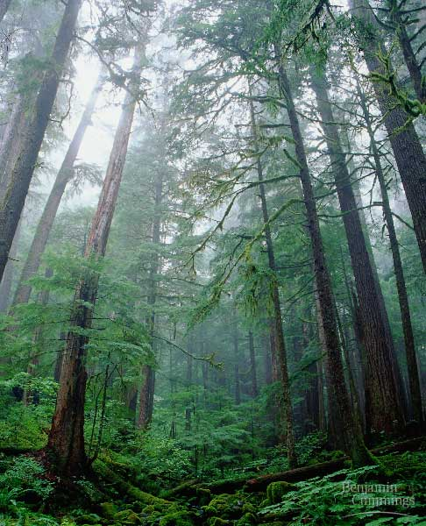

Water
The amount of drinkable fresh water has reduced due to pollution from sewerage, chemicals, salinity and sedimentation.
High levels of nitrogen have caused algae and bacterial blooms in many rivers (Eutropication) making them toxic.

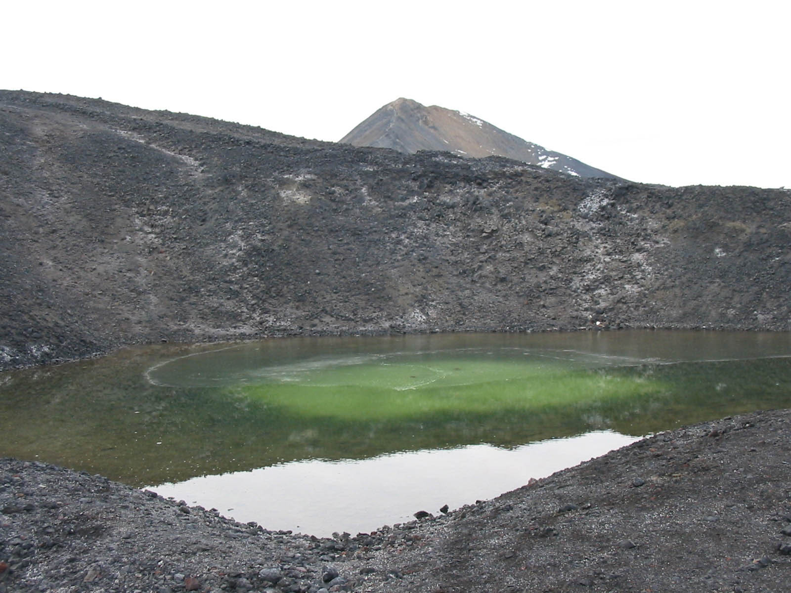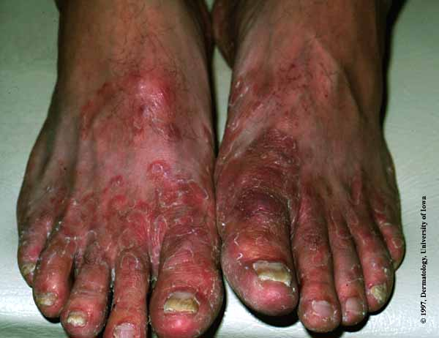
Air
Burning fuels such as fossil fuels and forests have increased the amount of waste gases (eg CO2) in the air. This combined with methane and CFC’s have resulted in more heat trapped in our atmosphere (Green House Effect) changing out temperature and weather.
CFC’s have collected in the upper atmosphere and this has created a thinning (hole) in our ozone layer. This allows cancer causing radiation through.
CO2 and SO2 are soluble gases and dissolve into the water in the clouds. This makes the water acidic and the rain becomes acidic (acid rain)
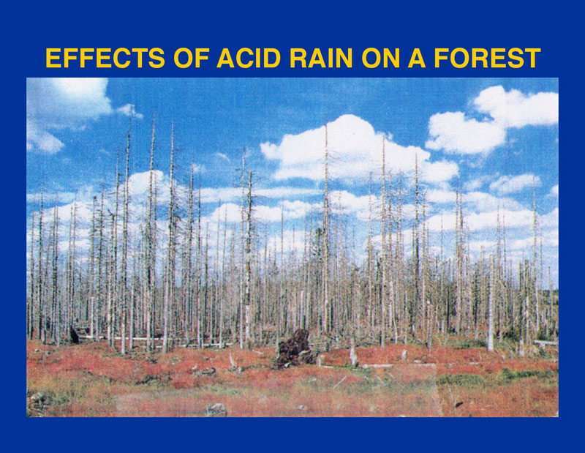

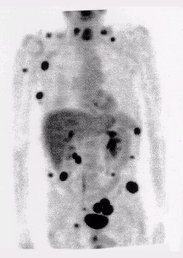

Pollution
Rubbish is released vast quantities. Plastic has entrapped animals (birds) and chocked then (whales). Heavy metals (lead, mercury and cadmium) have accumulated in animals, water and soils. Factory waste is commonly pumped into rivers and the oceans.
Pesticides are being used in larger doses and more concentrated forms to control weeds and insects.

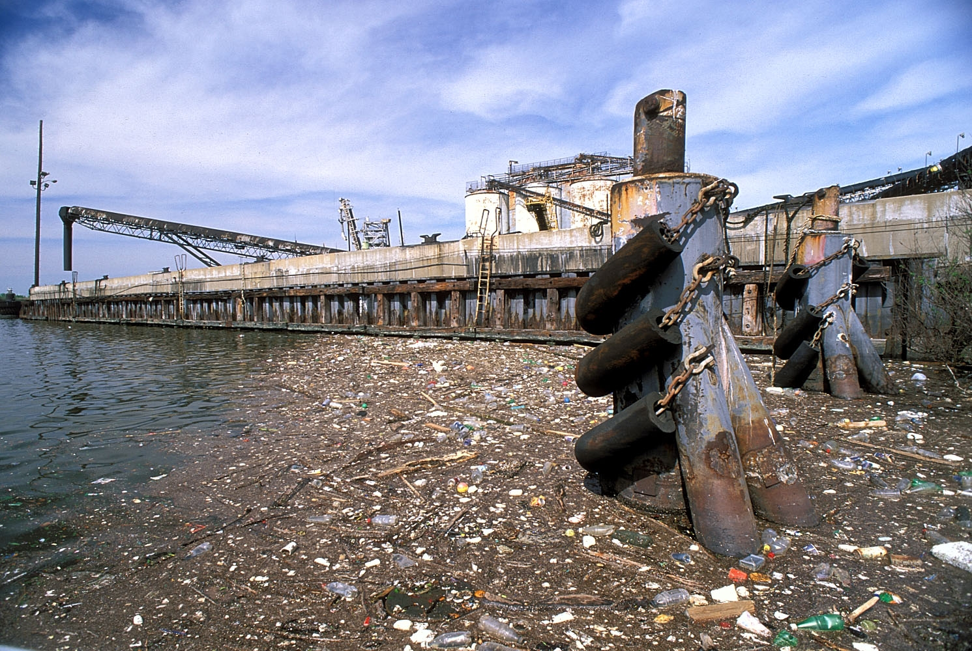

Food
The high demand for human food has meant bigger farms, over hunting, over fishing, altered ecosystems (snapper V blowfish)

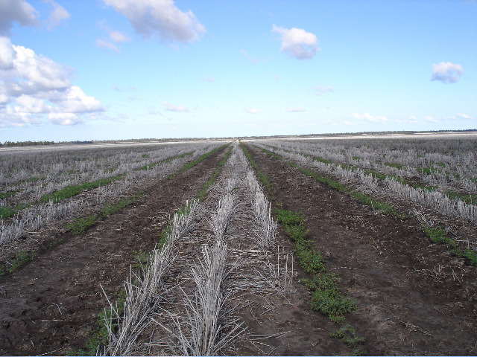

Foreign organisms
Introduced plants (eg. Skeleton weed and Patterson’s curse) have become invasive weeds and many areas are choked in weed growth that has no natural enemy.
Introduced animals (eg.rabbits, foxes) have exploded in numbers out competing local animals.
Biotechnology have allowed for the production of new organisms that have become resistant to toxins (eg. cereal crops) and concentrated farming like fish farms.


